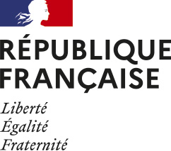
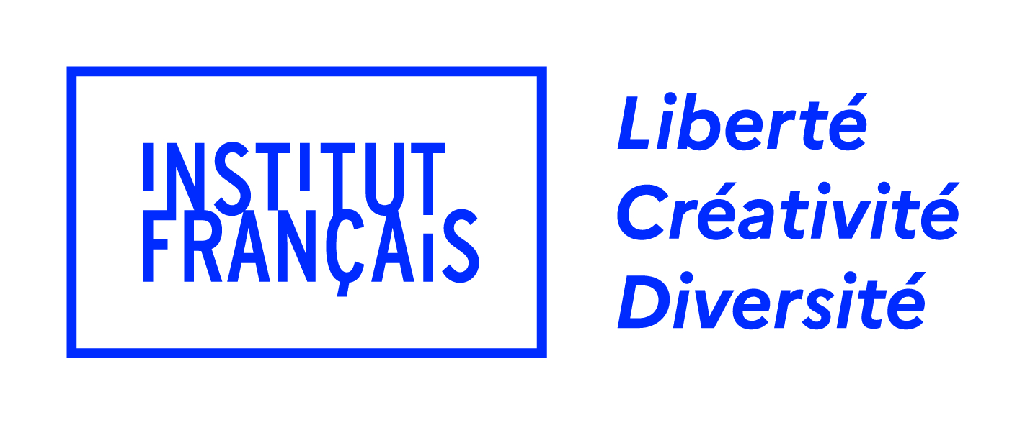
Press release

Paris, 11 May 2023

THE INSTITUT FRANÇAIS CELEBRATES WORLD CINEMA DURING THE CANNES FILM FESTIVAL!

A few days before the opening of the 76th edition of the Cannes Film Festival, the Institut français and its partners France Médias Monde and the Organisation Internationale de la Francophonie (OIF) are pleased to announce the programme of the Cinemas of the World Pavilion (International Village, Cinemas of the World Pavilion, N° 107).

The promotion and preservation of African film heritage, gender in the film industry, creation in times of war, documentary cinema and eco-responsible cinema will be among the topics addressed during this 2023 edition. The Pavilion will also be an opportunity to promote the diversity of the French cultural network's actions abroad.

Located in the heart of the International Village of the Cannes Film Festival, the Cinemas of the World Pavilion is a real working and meeting platform open to French and international stakeholders in the sector. Artists, professionals, institutions and representatives of the French diplomatic network abroad come together there. It highlights the actions of the Institut français in favour of French cinema and world cinema, in particular its flagship programme La Fabrique Cinéma, as well as the initiatives undertaken by its partners.

HIGHLIGHTS OF THE WORLD CINEMA PAVILION

Thursday 18 May
10:00-13:00: Shoot the Book! Masterclass

In partnership with the SCELF (Société Civile des Editeurs de Langue Française), Shoot the Book! is a programme of professional meetings designed to support the presence of French publishers on the major international audiovisual markets and to promote the audiovisual adaptation of French literary works of fiction. This 2023 edition will be dedicated to audiovisual literary adaptation in the Spanish-speaking markets (Spain, Argentina, Colombia and Mexico).

16:00-18:00: La Fabrique Cinéma from the Institut français - Pitches for the 10 projects
La Fabrique Cinéma, which will celebrate its 15th anniversary this year, is a programme run by the Institut français that promotes the emergence of young filmmakers from southern countries on the international market. Ten directors, accompanied by their producer, are invited to present their debut or second feature film project and to receive support in finding co-producers. Come and hear about the 10 film projects selected for the 2023 edition, from Argentina, Chile, Costa Rica, Egypt, India, Lebanon, Nigeria, the Philippines, Senegal and Tunisia!
Moderated by: Elias Ribeiro

Friday 19 May
11:30-13:00: Documentary film: the key role of festivals

On the occasion of the Year of the Documentary Film 2023, this round-table, organised in partnership with Cinéma du Réel, will examine the key role of festivals, both specialised and generalist, in the promotion of this rapidly growing cinema, rich in singular works and formidable diversity. The challenge currently is to transform this increased interest in documentary cinema into a genuine attraction for the distribution and screening circuits as well as for cinema audiences.

In partnership with Cinéma du Réel
Moderated by: Catherine Bizern
Participants: Alice Lesort (Les Films du Losange), Anna Alice de Morais (Rencontres Internationales de Documentaire de Montréal), Julie Paratian (Sister productions), Christoph Terhechte (DOK Leipzig), Barbara Wurm (Berlinale Forum)...

15:00-16:15: Parity, equality, diversity! International perspectives - By Le Collectif 50/50
Where do we stand on parity and the fight against sexist and sexual violence in the film industry as we approach the fifth anniversary of #metoo? This round table will be an opportunity to take stock of the situation, share experiences and best practices, and compare views from around the world, in the service of international sisterhood.

A session presented by Le Collectif 50/50
Created in 2018, Le Collectif 50/50 works for equality, parity and diversity in the French cinema and audiovisual sector. Made up of industry professionals, it develops studies, formulates measures with public authorities, and creates concrete tools to accelerate change in front of and behind the camera.
Moderated by: Margaux Lorier | Le Collectif 50/50 | producer | France | Clémentine Charlemaine | Le Collectif 50/50 | General Delegate of Cinéma Pour Tous | France
Speakers:
Sawsan Yusuf - Producer | Egypt
Juliana Funaro - +Mulheres / producer | Brazil
Heather Rabbatts - Time's Up UK | United Kingdom
Andria Wilson Mirza - Women in Film | USA

Saturday 20 May
17:00-18:30: Supporting creation, from Kyiv to Tehran
In collaboration with the Association du Cinéma Indépendant pour sa Diffusion (ACID), this panel will propose a discussion between directors, producers and residency managers on the issue of creation in times of war and crisis, and on support mechanisms for these creators who often work with their lives at risk.

In partnership with ACID
Participants: Kaveh Farnam (producer, Iranian Independent Filmmaker Association), Maciek Hamela (director, ACID selection-Cannes 2023), Jean Laurent Csinidis (producer, Films de Force Majeure), Anne Devauchelle (L'Usage du Monde au 21è siècle)...

Also in attendance will be representatives of the CNC (Caméra libre!, European Solidarity Fund for Ukrainian films) and Dounia Sichov (Chief editor, Mariupolis 1 and 2 by Mantas Kvedaravicius).

Moderated by: Reza Serkanian (director - ACID)

Sunday 21 May
11:30-13:00: Conference - Organisation Internationale de la Francophonie: 2022 review and results of the May commissions

The IOF support fund will make public the results of its two May commissions (Fiction Cinema / Documentary-Series) and will also present the latest developments of Clap ACP, its programme in favour of South-South co-productions conducted with five support funds based in Africa.

15:00-18:00: Sembène Ousmane (1923-2023) – Reinventing the Future: African film heritage tribute and discussion

"Itʼs up to us to create our values, to recognise them, to carry them around the world, but we are our own sun" Sembène Ousmane

Sembène Ousmane would have been 100 years old this year. A writer and filmmaker, he remains a leading figure and icon in the field of literary and cinematographic creation. Bridging continents, his integrity, tenacity and faith in Africa are shared by the youth of today. This is an opportunity to rediscover and reappropriate a heritage that opens the doors to a possible future based on the values dear to Sembène: commitment, dignity, independence, transmission.
This round table will allow us to pay tribute to this iconic figure of African cinema and discuss the issues of preservation and promotion of African film heritage.

In partnership with: La Fepaci, Les éditions Vives Voix, Fonds d’Archives Africain pour la Sauvegarde des mémoires, Canal Plus, RFI, TV5 Monde, Organisation Internationale de la Francophonie, Héliotropismes, Pavillon Afriques, Pavillon Africain and Cinetek

Speakers: Valérie Berty (Doctor of Literature, Sembène un homme debout), Renaud Boukh (Héliotropismes editions), Cheick Oumar Sissoko (filmmaker), Ghaël Samb Sall (Director of Vives Voix editions and President of the Fonds d’Archives Africain pour la Sauvegarde des Mémoires), Marco Lena (Audiovisual Archivist, Executive Director of the Fonds d’Archives Africain pour la Sauvegarde des Mémoires), Béatrice de Pastre (CNC - Cinematographic Heritage Directorate)...

Moderated by: Catherine Ruelle (Author, journalist and film critic)

La Fabrique Cinéma Monde is a programme designed and presented by the Institut français, in close collaboration with the Cannes Film Festival, in partnership with France Médias Monde (RFI, France 24 and Monte Carlo Doualiya) and the Organisation Internationale de la Francophonie. On the occasion of this special edition, TV5 Monde will also be a partner of the 15th anniversary of Fabrique Cinéma.

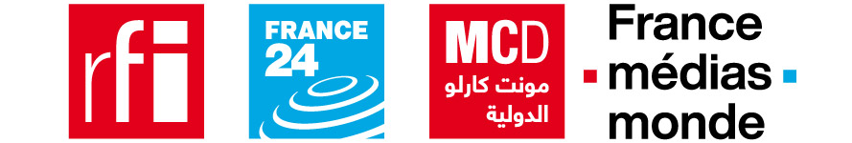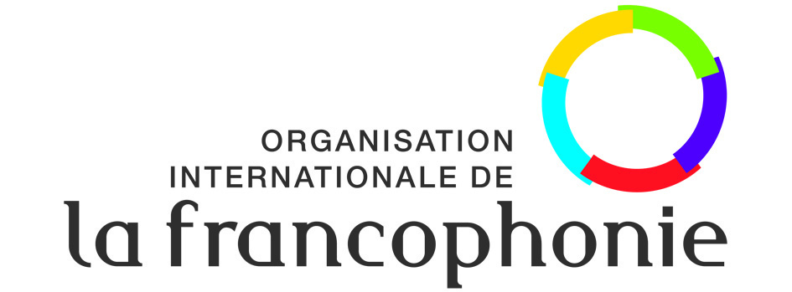

L’Institut français
As a key stakeholder in cultural policy outside France, the Institut français is entrusted with a public service mission and financed by state subsidy.The Institut français, under the dual supervision of the Ministry of Europe and Foreign Affairs and the Ministry of Culture, conducts three fundamental missions.
- To promote French culture and language around the world
- To strive for cultural diversity around the world
- To amplify the action of the French cultural network abroad

For more information: https://www.lescinemasdumonde.com/en

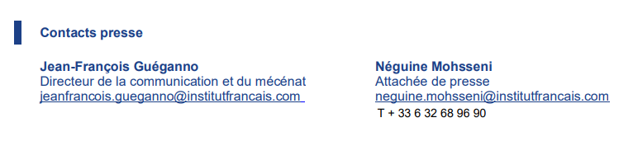

AGNES RENOULT COMMUNICATION
ifcinemasdumonde@agnesrenoult.com
T : 01 87 44 25 25

